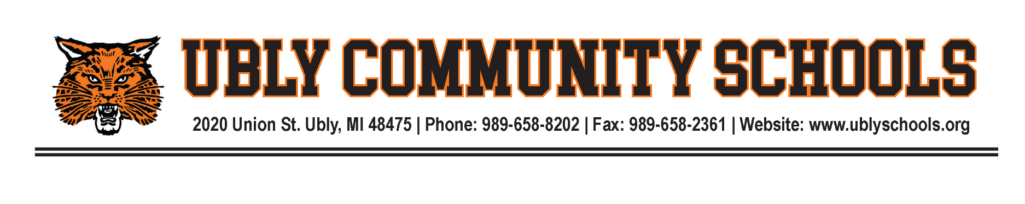

January 12, 2025

Dear Parents and Community Members:

We are pleased to present you with the Annual Education Report (AER) which provides key information on the 2023-2024 educational progress for the Ubly Elementary School. The AER addresses the complex reporting information required by federal and state laws. The school’s report contains information about student assessment, accountability, and teacher quality. If you have any questions about the AER, please contact Ubly Elementary Office for assistance.

The AER is available for you to review electronically by visiting the following web site www.ublyschools.org, or you may review a copy in the main office at your child’s school.

For the 2023-2024 school year, schools were identified based on previous years’ performance using definitions and labels as required in the Every Student Succeeds Act (ESSA). A Targeted Support and Improvement (TSI) school is one that had at least one underperforming student subgroup in 2023-2024. An Additional Targeted Support (ATS) school is one that had a student subgroup performing at the same level as the lowest 5% of all schools in the state in 2023-2024. A Comprehensive Support and Improvement (CSI) school is one whose performance was in the lowest 5% of all schools in the state or had a graduation rate at or below 67% in 2023-2024. Some schools are not identified with any of these labels. In these cases, no label is given.

Our school has not been given one of these labels.

When looking at the MI School Data site under the Annual Education Report-Combined Report, the most relevant take away from the data is the information on scores from students in the socio-economic status and proficiency on state assessments. Across all subject areas and grade-levels, students categorized as “economically disadvantaged” scored lower on the assessments than those who were not considered economically disadvantaged. Ubly Elementary School has supports in place to help these students including Title Interventions.

State law requires that we also report additional information:

1. Ubly Elementary School has an open enrollment and is the only elementary school in the Ubly School District.

2. Ubly Elementary School yearly updates the school improvement plan. The School Improvement Plan includes goals for increased achievement in Math, Reading, and Writing and includes strategies and activities such as the use of evidence-based literacy instruction, differentiated instruction, Strategic Intervention Solutions, Great Expectations, Kagan Cooperative learning, 21ST Century Math Instruction Strategies, Science of Reading Instruction and technology to accomplish those goals. Our school is now using the MICIP (Michigan Continuous Improvement Plan) system to coordinate our school improvement goals.

3. Ubly Elementary students are eligible to attend three specialized schools that are operated by the Huron Intermediate School District as well as several CTE programs. Descriptions can be found at: http://www.huronisd.org

4. Ubly Elementary concentrates on the Common Core Standards. These standards can be obtained from each classroom teacher or from this website: https://corestandards.org/

5. Student Achievement Data: M-STEP Proficiency Rates

Grade/Subject | 2020-21 | 2021-22 | 2022-23 | 2023-24
3rd Grade Math | 71.1 | 48.8 | 58.1 | 65.7
3rd Grade English | 64.9 | 46.4 | 51.2 | 48.6
4th grade Math | 32.5 | 67 | 42.9 | 66.7
4th grade English | 53.8 | 53.9 | 50.0 | 48.9
5th Grade Math | 22.6 | 28.6 | 47.5 | 32.6
5th Grade English | 60.4 | 63.4 | 65.0 | 56.5
5th Grade Social St | 13.2 | 31 | 37.5 | 34.8
5th Grade Science | 50.9 | 66.7 | 65.0 | 50

6. 95% of students at Ubly Elementary School had their parents attend Parent-Teacher Conferences on October 10, 2024.

The staff at Ubly Elementary School Greatly appreciates the opportunity to work with all our students and we ask that any parent or community member to please contact us if there are any questions about our educational programs or regarding any activities at the school.

Sincerely,
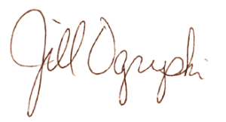
Jill Ogryski
Principal
Ubly Elementary School

